J3ZZ LIVE SOLO – HOSPITALITY

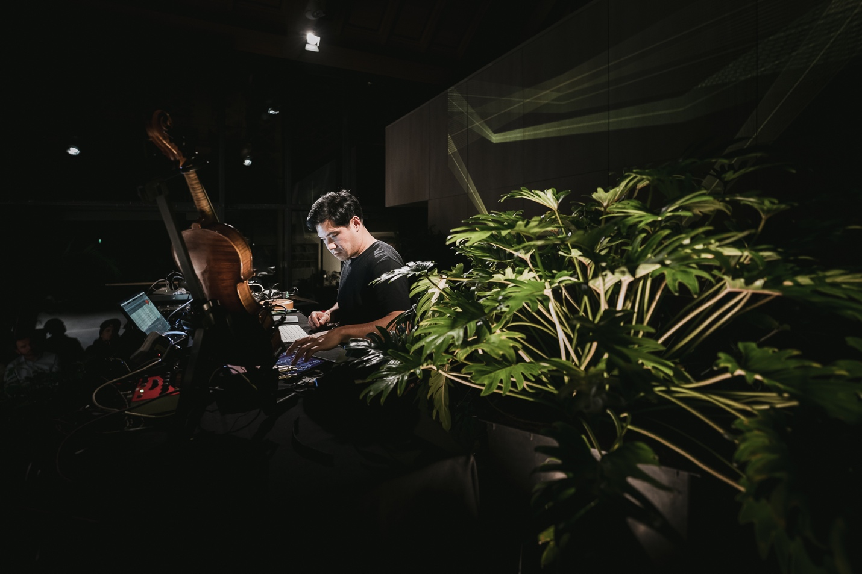
First of all, thank you for your interest in booking a show for J3ZZ Live Solo. Below is a list of our technical requirements. It might sound a bit formal to you, this is not meant to cause any inconveniences on your behalf. We designed this rider for optimum effectiveness at the day of the show. If there are any questions or if you have trouble providing any of the below mentioned please get in touch with us before the day of the show and we will work out a solution.

Contacts
Jérôme Li-Thiao-Té (J3ZZ) – Main Artist, Mic speaker. (L)
Aric Resnick – Booking / Sound engineer FOH. (XL) - +36 70 708 7818

Travel, Hotel, Dressing rooms and Catering
PURCHASER agrees to provide ARTIST’S REPRESENTATIVE with detailed directions to the place of performance. If ARTIST gives advance notice to PURCHASER that the ARTIST is arriving by air, PURCHASER shall, at his sole cost and expense, provide GROUND TRANSPORTATION for ARTIST’S entourage of two (2) people, plus luggage and instruments, etc. between airport, hotel, concert, venue, and return to airport upon departure.
If PURCHASER is providing HOTEL ACCOMMODATIONS, The rooms shall be available until the day after the performance with the ARTIST to comply with checkout times and hotel rules. Rooms shall be noise free, as well as completely dark, within close proximity to the venue, and CONTAIN BALCONIES and/or WINDOWS THAT OPEN.
PURCHASER shall provide one (1)+ comfortable and private DRESSING ROOM. This room must be clean, dry, well-lit, heated or air-conditioned, shall contain at least chairs and shall be within easy access to clean and private lavatories which are supplied with soap, toilet tissue and plenty of clean towels (minimum 3). Towels shall be provided for ARTIST’S use in dressing rooms and on stage. A professional steamer (preferred) {or iron with ironing board} is required in band dressing room.
PURCHASER shall guarantee adequate SECURITY at all times to insure the safety of the ARTIST’S personal instruments and personal property from the beginning of load-in to completion of load-out. During soundcheck, performance, and after show, PURCHASER will have security backstage, on-stage, and at the mixing console. PURCHASER is held responsible for the personal belongings and for all equipment of the ARTIST.
HOSPITALITY: PURCHASER shall provide refreshments and meals in quantities sufficient for three (3) persons, available from bands arrival until departure.
A good supply of Coffee with and without caffeine, Tea Water, and Soft drinks should be available at this time. Mineral waters, beers, single malt whiskey, dried fruits, sugar, lemon, and honey should be provided, with spoons and an ashtray.
CHECK and remain available through load out.
Menu Suggestions: Fish or Chicken with Rice and Vegetables, additional vegetable side dish, fresh bread and butter etc. ** No deep-fried or “fast” food please.**
PURCHASER shall also provide the name and address of a good quality restaurant for after the performance, restaurant should be at open between 11pm and midnight.

